MACH4METAL

metalworking machinery
Transito 21, 6909 DA Babberich, Netherlands
Tel. + 31 (0)316 – 247123
Fax. + 31 (0)316 - 247956
info@mach4metal.com
www.mach4metal.com
Bank No : 66.52.13.883
IBAN : NL33 INGB 0665 2138 83
BIC : INGBNL2A
VAT : NL 815393635B01

TACCHI CNC HD 3 / 105
Ø 1450 x 10.000 mm

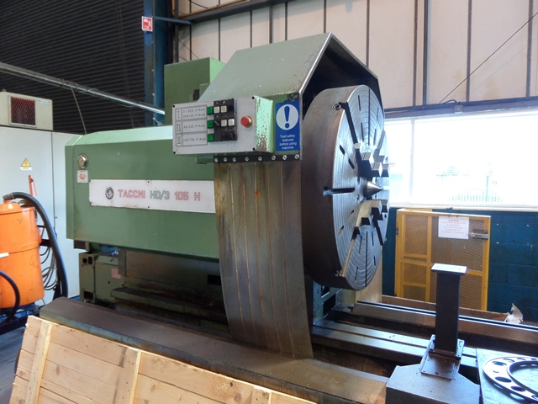
- Make : TACCHI Italia
- Typ : HD/3 105 H CNC
- Serial : …….
- Age :

- Centre height : 725
- Swing over bed Ø : 1.400
- Swing over slide Ø : 1.000
- DBC turning length : 10.000
- Spindle bore : 150
- Bed width 3 guide : 1.050
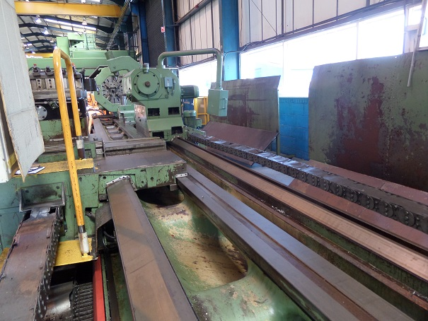

- Spindle speeds 1e stage : 2.5 – 80
- Spindle speeds 2e stage : 80 - 240
- Spindle speeds 3e stage : 240 – 720
- Spindle main power Kw : 50 / 80

- Work load in chuck : 3.800
- Work load between centres : 16.000

- Feed / Stroke X axis : 650 / 6.000
- Feed / Stroke Z axis : 9.000 / 6.000
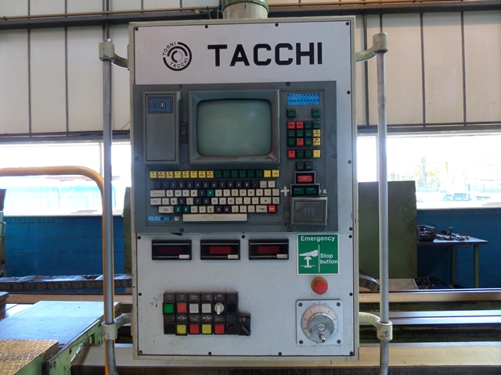
- Pinole quill : Ø 215
- Stroke : 300
- Spindle Taper : Metric 80

Please Note: The above information has been obtained to the best of our ability and belief from, and from the manufacturers where possible. It is given in good faith, but its accuracy can not be guaranteed. Accordingly, it will not form a representation or constitute contractual terms. We advise you to check any vital details!

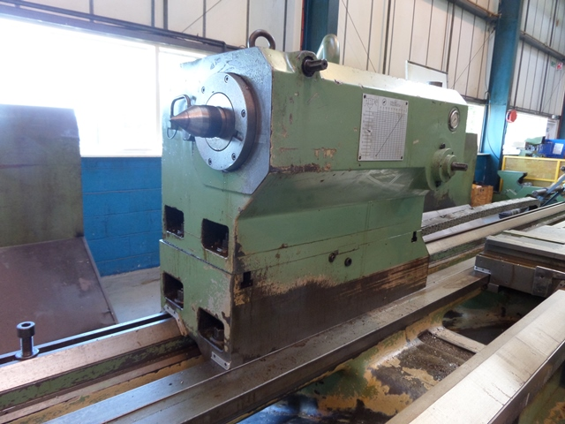
- Baraffaldi 4 positions revolver

- Chip conveyor on full length
- 1 x Fixed steady rest Ø 750
- 1 x Fixed steady rest Ø 1000
- 1 x Heavy duty boring bar 2000 x 175

- 4 chuck Ø 1.200 ?
- 4 chuck Ø 1……?
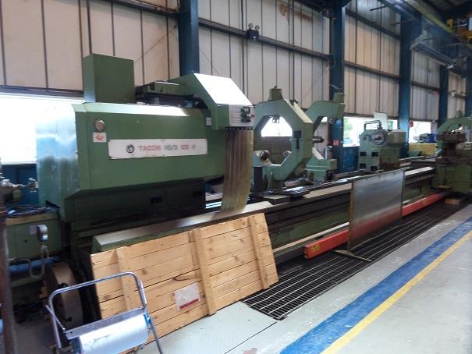

- ECS 2302 in ….
- Motorized tailstock

- Dimensions
- Length : 14.600
- Width : 4.330
- Height : 3.300
- Weight : 42.600

- Under power at Rolls Royce Plant Edenborough
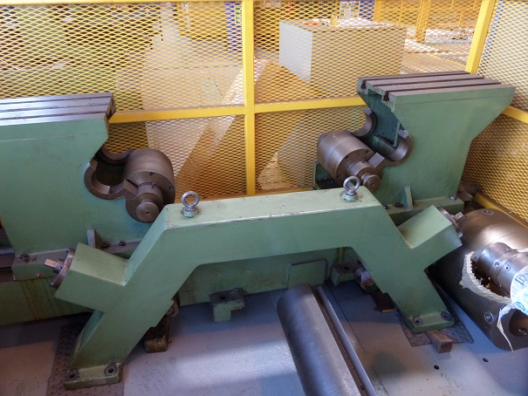

Please Note: The above information has been obtained to the best of our ability and belief from, and from the manufacturers where possible. It is given in good faith, but its accuracy can not be guaranteed. Accordingly, it will not form a representation or constitute contractual terms. We advise you to check any vital details!

